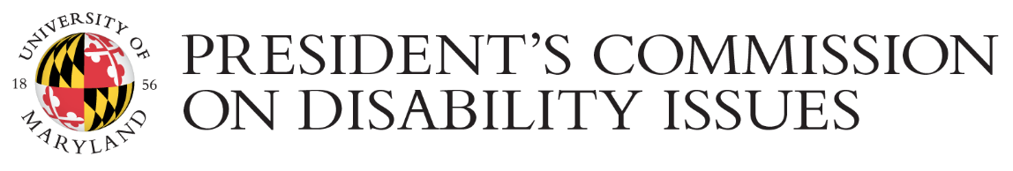

2015 Disability Awareness Month

LIST OF EVENTS

Emergent Intersections of Disability and the Digital
FRI Oct 2nd | 2:30 - 4:00 P.M. | Prince Frederick Hall, Room 1105
A roundtable during the conference “Transformative Digital Humanities” features M.W. Bychowski, Angel Love Miles, Izetta Mobley, and Jarah Moesch and is moderated by Beth Haller.

National Day Without Stigma
MON Oct 5th | 6 - 9:00 P.M. | Jimenez hall Room 0105
During this panel, students share their mental health stories with the audience. A question-and-answer period and discussion follow.

Alive Inside
TUE Oct 6th | 6:00 P.M. | Van Munching Hall, Frank Auditorium Room 1524
Join us for this powerful and moving 2014 Sundance Film Festival award winner. View the trailer that went viral at aliveinside.us.

Best Practices for Making Course Content Accessible
TUE Oct 13th | 12:30 - 1:00 P.M. I Webinar
Word files, PowerPoints, PDFs. Learn how to make this content accessible to all students in an ELMS course.

Campus 30year IT-Accessibility Plan
TUE Oct 20th | 3 - 5:00 P.M. | Patuxent Building, Room 0120
Get an overview of and discuss the plan’s strategic areas: Web accessibility, course (re)design, multimedia development, e-learning collaborative tools, and assistive technology tools. RSVP to kbracagl@umd.edu by Oct. 16.

Radical Access, Disability Justice, and Awkward Ableism
FRI Oct 23rd | 12 - 2:00 P.M. |SPH Deans Conference Room, Room 2242h
Signup is required. Email anapella@umd.edu. This workshop is supported by a Maryland Moving Forward grant.

ELMS Course Accessibility Boot Camp
MON OCT 26th | 2:30 - 4:00 P.M. | McKeldin Library Room 6103
Work with DIT Learning Technology Services instructional designers to check your course space for accessibility roadblocks and fix them.

Bathroom Justice
TUE OCT 27th | 5:30 - 8:00 P.M. | McKeldin Library Special Events Room, 6103
Bathrooms are where race, gender, sexuality, and ability intersect. Everyone should be “Free 2 Pee.”

Disabilities Studies Roundtable
THU Oct 29th | 10 - 11:35 A.M. | Susquehanna Hall, Room 1111
Join us in the continued discussion of establishing a multidisciplinary disability studies minor. This event
is supported by a Maryland Moving Forward grant.
Disabilities and Reasonable Accommodations: The Law, Etiquette, and Ethics
THU NOV 5th | 1 - 4:00 P.M. | McKeldin Library, Special Events Room 6137
This workshop is presented by lawyers and educators from the Maryland Commission on Civil Rights.

Contact PCDI at pcdi@umd.edu or (301) 405-2608 if you have any questions or need to request any accommodations that will facilitate your full participation in the events, such as seating arrangement, ASL interpreting, assistive listening devices, captioned videos, Braille, handouts in large print or electronic format, etc. Learn more about the President’s Commission on Disability Issues at https://pcdi.umd.edu

Updated 09/19/2019

