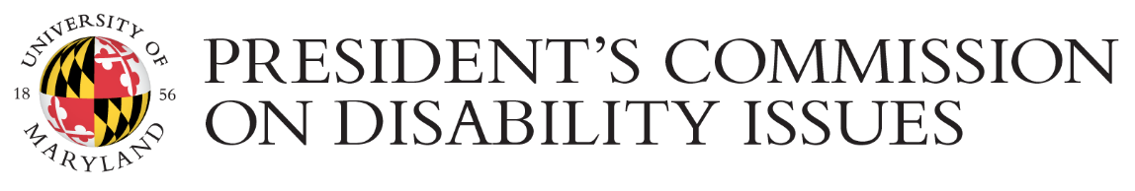

2017 Disability Awareness Month

LIST OF EVENTS

Kickoff Party with “Margarita with a Straw” Movie
FRI Oct 6th | 1 - 4:00 P.M. | STAMP Union Student Involvement Suite 0207
Join EDSP220 and our community for a gathering to discuss the future of disability identity in America. We will show the Toronto Film Festival and 4-time international award winning film “Margarita with a Straw”.

Do You Dream in Color?
THU Oct 12th | 4 - 6:00 P.M. | Edward St. John Building Room 0201
The National Federation of the Blind presents the coming-of-age story of four courageous blind high school students as they strive to prove that their disability will not hold them back from achieving their dreams. Movie followed by panel with audience question and answer.

Using ELMS Accessibility Tools
FRI Oct 13th | 10 A.M. - 12:00 P.M. | Edward St. John Building, Room 1103
Learn how to use several powerful tools available within ELMS to ensure the accessibility of course content.

RadAccess Workshop
MON Oct 16th | 2 - 4:00 P.M. | McKeldin Library Special Events Room 6137
Join this interactive workshop which offers the basics of ableism and what radical access and disability justice means. This workshop is meant for people in solidarity with disability justice movements.

Yoga for Peace: honoring ourselves and our community
TUE Oct 17 | 12 - 1:00 P.M. | Behind University Chapel
Join us for a moment of silence, meditation and gentle yoga for peace and compassion toward ourselves and our community

Exploring Goalball
FRI Oct 20 | 4 - 5:30 P.M. |McKeldin Library Room 6107
Goalball is the exciting and emerging team sport designed specifically for blind athletes. This panel will offer attendees an opportunity to learn about Goalball and interact with experts and players of the sport.

Capital City Goalball Tournament
SAT OCT 21st / SUN OCT 22nd | 9 A.M - 5:00 P.M. | School of Public Health GYM2101
Tournament organized by the Metro Washington Association of Blind Athletes. Recreational and competitive sports opportunities should be open to everyone, regardless of their ability to see. Enjoy this exciting game and meet blind athletes and their sighted peers.

SHARK TANK
WED Oct 25th | 4:30 P.M. - 6:00 P.M. | Hornbake Building South Wing Career Center Room 3135
You know the drill. The Sharks have the last word. Students solve real world problems in teams and compete for the #FEARLESSINCLUSION award. Bring a team or pair up on the spot. Major employers/business Orgs will judge your idea or product and deliver the verdict.

Disabled Heroes in Video Games
THU Oct 26th | 4 - 6:00 P.M. | McKeldin Library Room 7121
Try Perception and HellBlade video games, which include disabled heroes and engage in a discussion about disability in the media. No previous experience with video games required.

PCDI Town Hall: Fostering a Community of Disability at UMD
FRI Oct 27th | 12:30 - 2:00 P.M. | Edward St. John Room 1202
Disabled students, faculty, and staff members of UMD — as well as friends, family, and allies — are invited to this town hall discussion about how to grow, strengthen, and sustain a community of disability at the University of Maryland.

Workforce Recruitment Program: Get an Internship! Get a Job!
10/2 12 noon Hornbake South 3135c
10/11 Webinar (check careers.umd.edu events calendar for details)
10/12 4:30–5:30pm Hornbake South 3134
The WRP recruitment and referral program connects federal and private sector employers nationwide with highly motivated college students and recent graduates with accommodations or disabilities eager to prove their abilities in the workplace through summer or permanent jobs. Come meet the WRP Campus Coordinator and learn more: www.wrp.gov

Contact PCDI at pcdi@umd.edu or (301) 405-2608 if you have any questions or need to request any accommodations that will facilitate your full participation in the events, such as seating arrangement, ASL interpreting, assistive listening devices, captioned videos, Braille, handouts in large print or electronic format, etc. Learn more about the President’s Commission on Disability Issues at https://pcdi.umd.edu

Updated 09/19/2019

